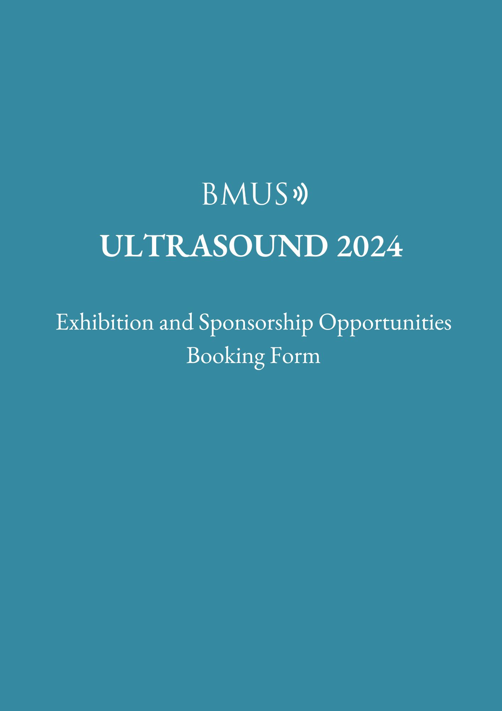

Sponsorship and Exhibition Packages:
If you are interested in a Gold, Silver or Bronze Sponsorship Package. Please complete the table below
Sponsorship Package | Stand Number
Gold sponsorship:  £14,750*  15 points for additional options | Choice 1
 | Choice 2
Silver sponsorship:  £13,500*  10 points for Additional options | Choice 1
 | Choice 2
Bronze sponsorship:  £10,000*  6 points for Additional options | Choice 1
 | Choice 1

If you are interested in a shell scheme stand, please complete the section below.
Exhibition Package | Stand Size | Stand Number | Shell Scheme or Space Only
Stand Choice 1
Stand Choice 2
Stand Choice 3

*Please note all orders are subject to VAT at 20%

This form constitutes your agreement and

must be returned to complete your booking
You can post or fax this form back to:
Emma Tucker, BMUS, Margaret Powell House, 405 Midsummer Boulevard,
Milton Keynes MK9 3BN
Alternatively scan to emma@bmus.org

Additional Options

These are options you can spend your points on. Gold 15 points, Silver 10 points and Bronze 6 points. For Shell Schemes points need to be pre-purchased. Please mark how you would like to spend your points in the selection column.

Ad on Options |  | Selection
Social Events
Sponsor the Winter Ball (1 available) | 9
Sponsor the Drinks Reception (1 available) | 5
Branding
Logo on Lanyards (1 available) | 6
Logo on Volunteer T-Shirts (1 available) | 3
Logo on the Delegate Bag (1 available) | 6
Pads and Pens for the Delegate packs (1 available) | 2
Marketing
Advert in Programme (Included in Gold Silver and Bronze package)
Full Page | 3
Half Page | 2
Advert on the Event App/Microsite (Included in Gold Silver and Bronze package) | 1
Advert on the A1 Wall Planner (Included in Gold Silver and Bronze package) | 1
One item in Delegate Bag (Included in Gold Silver and Bronze package) | 2
1 Company article/Advert in Ultrapost | 3
Logo on the landing page of the Conference website (Included in Gold Silver and Bronze package) | 2
1 qtr page advert in August Edition of BMUS News (Printed) | 3
1 qtr page advert in November Edition of BMUS News (Digital) | 3
Educational
Sponsor DMB (1 available) | 3
Sponsor the Young Investigator Session (1 available) | 3
Useful Extras
Room within Conference Space (limited availability) | 4
Lecture Pass for all 3 days | 1
6 Additional Lunch tickets for all 3 days | 1
Purchase Additional points | £500 = 1
Total Points

Company Details:
Company Name:
Name:
Position:
Invoice Address:

Purchase Order Number:

Tel:

Email:

Accounts Payable e-mail:

Signed:

This form must be completed in full to be accepted

BOOKING CONDITIONS

1. Any relevant purchase order should be should be returned with the booking form within 7 working days to enable an invoice to be raised. Notwithstanding a 33% booking deposit should be made within 14 days, with a further 33% (66% of booking) to be paid by 5th September 2024.
2. Full payment MUST be received by 6th November 2024; outstanding debtors will not be admitted to the meeting.
3. Please note all charges are exclusive of VAT and chargeable at the prevailing rate of 20%.
4. Booking cancellations must be made in writing to Emma Tucker at the address above or by e-mail to emma@bmus.org. No other form of cancellation is accepted.
5. Written cancellations received 28 days prior to conference will be subject to a 50% cancellation fee, and cancellations post 28 days prior to conference are subject to the full charge.

Full Terms and Conditions at rear of document.

Payment Details

Bank: Unity Trust Bank
Sort Code No: 08-60-01 Account Number: 20247031
IBAN: GB93 NWBK 6002 3571 4180 24 SWIFT: NWBKGB2L
Please quote the booking reference on your remittance

Terms and conditions

1. DEFINITIONS
In these Standard Terms and Conditions the word ’Sponsor/Exhibitor’ means any company, organisation or person who has applied for space allocation in an exhibition and/or to sponsor an event, or their agent, contractor or employee. The word ‘Organiser’ means British Medical Ultrasound Society.

2. STAND BOOKINGS
Sponsors/Exhibitors must complete sign and return the booking form. Provisional bookings can be held for 14 working days; however no application will be considered valid until a signed booking form and payment is received. The Organiser reserves the right to refuse any bookings at any time without stating a reason. A booking is only confirmed when accepted by the Organiser in writing.

3. PAYMENT TERMS
An invoice will be raised on receipt of a booking form with 33% of booking due within 14 days of placing the order; the 2nd stage payment is due on 5th September 2024 with the final payment of 33% due on 6th November 2024. Where the invoice amount is not paid within the prescribed time, stands and sponsorship packages may be Reallocated and any loss incurred by the Organiser by such non-payment shall be claimed from the defaulting Sponsor/Exhibitor.

4. CANCELLATION
All cancellations must be made in writing and are subject to a 25% administrative cost withheld from the original payment.
Cancellations made within 60 days of the event will be liable to a further 50% cancellation fee. Cancellations made within 28 days of the event will be liable for payment of the total invoice amount for the original booking.

5. AMENDMENT OF EXHIBITION FLOOR PLAN
While every endeavour is made to retain the published plan of the exhibition, the Organiser shall be entitled to vary the layout if it believes such variation to be in the general best interests of the exhibition as a whole.

6. SECURITY AND INSURANCE
Neither the Organiser nor its contractors shall be responsible for the safety and security of the exhibit or of any other property of any Sponsor/Exhibitor, its agents or employees, or for the loss, damage or destruction by theft or fire, or from any other cause, to such exhibits or other property, or for loss, damage or injury sustained by any Sponsor/Exhibitor or any other person save where proved to be caused by the negligence or breach of duty of the Organiser. The Sponsor/Exhibitor shall indemnify the Organiser and its contractors against any liability incurred by the Organiser or its contractors to third persons, as a result of any act or omission of the Sponsor/Exhibitor, its employees or agents. The Sponsor/Exhibitor should effect its own insurance against the risk of any loss, damage or injury or liability.

7. POSTPONEMENT OR ABANDONMENT
The Sponsor/Exhibitor shall have no claim against the Organiser or its contractors in respect of any loss or damage caused by the prevention, postponement or abandonment of the event, for reasons beyond the control of the Organiser or its contractors.

8. SUBLETTING AND SHARING OF STANDS
The Sponsor/Exhibitor shall neither share with, nor part with possession of the whole or any part of the stand allocated to it, to another organisation, company or person without the written consent of the Organiser.

9. STAND FITTINGS REGULATIONS
The Sponsor/Exhibitor and its contractors may not interfere with the exhibition building in any way whatsoever, and any damage caused by their acts of negligence shall require them to indemnify the Organiser and its contractors against any claim arising from such damage.

10. ACCESS AND STAND DISPLAYS
The Sponsor/Exhibitor must ensure that its stand is ready before the opening of the exhibition each day. Stands must be fully staffed and stocked at all times. The Sponsor/Exhibitor must comply with build-up, breakdown and delivery times, as set out in the Sponsor/Exhibitor manual. Late build up and
early breakdown creates problems in exhibition halls, contravenes health and safety regulations and is discourteous to other Sponsor/Exhibitors. If late setup is unavoidable, a suitable time slot will be allocated by the Organiser at its discretion. Exhibits are not to be removed until the exhibition is closed, and any Sponsor/Exhibitors closing the stand before that time without the permission of the Organiser will be liable for an early closing fee of 25% of the total invoice amount. The Sponsor/Exhibitor must vacate its stand, and ensure that all exhibit items are removed from the premises, within the time specified for exhibition breakdown.

11. UNDESIRABLE ACTIVITIES
If it appears to the Organiser that the Sponsor/Exhibitor may be engaged in activities which it considers to be contrary to the best interests of the Exhibition or event or which appear unethical or unlawful, the Organiser may without being under any liability to refund or reduce any costs, cancel any stand booking or sponsorship package and require the Sponsor/Exhibitor to vacate the event forthwith and to refuse the Sponsor/Exhibitor the right to participate further in the event. Canvassing for orders, except by the Sponsor/Exhibitor on his own stand in the normal course of his business is strictly prohibited and in any such case the right to expulsion referred to above will be exercised at once. The distribution or display of printed or other placards, flyers or circulars or other articles except by the Sponsor/Exhibitor on its own display space is prohibited, except by prior written agreement with the Organiser.

12. SAMPLING CONSUMABLES
If the Sponsor/Exhibitor wishes to sample consumables it must ensure that it complies with sampling regulations as laid out by the venue’s contract and caterers. Consumables may be subject to corkage.

13. HEALTH & SAFETY AT WORK ACT
It is the responsibility of the Sponsor/Exhibitor to ensure that its
contractors’ employees’ and agents’, displays and exhibits comply with current legislation regarding Health & Safety at Work.

14. DISPOSAL OF WASTE
It is the responsibility of the Sponsor/Exhibitor to ensure that all debris and waste material arising from its own stand fitting is completely removed from exhibition area prior to the opening of the exhibition. Failure to comply with this procedure shall render the Sponsor/Exhibitor liable for the cost of clearance by the Organiser.

15. SPECIAL HAZARDS
Any exhibit that may be regarded as constituting a special risk or hazard must be notified to the Organiser at least one month in advance of the opening of the exhibition. The Sponsor/Exhibitor must at its own expense, comply with any conditions or safety precautions the Organiser, venue licensor or local authority may impose.

16. SPONSOR / EXHIBITOR/ EXHBITOR GUEST BADGES
Please note that Sponsor / Exhibitor / Exhibitor Guest badges will not grant access to any of the conference sessions and allow access only to the technical exhibition. Individual employees, agents, or contractors from sponsoring/exhibiting companies or organisations who wish to attend the conference sessions must register as full conference delegates.

17. DELEGATE NUMBERS
Whilst the Organiser will make every effort to secure a high level of
attendance of delegates, there can be no guarantee of delegate numbers and no discounts or refunds are available if delegate numbers do not reach the projected levels.

18. AGREEMENT
These Standard Terms and Conditions, together with the booking form, printed sales material, letter of confirmation and any subsequent agreed variations in writing and signed by the Organiser shall represent the entire Agreement between the Organiser and the Sponsor/Exhibitor and shall supersede any previous agreements or representations whether written or oral.

